

CECS 447 Fall 2021 Project #1

Digital Piano

By

Tam Doan

This projects simulates a piano digitally using DAC, a speaker, and an amplifier

Introduction

This project is the digital piano. The project has 2 modes, auto play and manual play. In autoplay, the piano will loop through 4 different songs in a round robin order and will play each song until interrupted. The 4 songs are: happy birthday, twinkle twinkle little star, Mary Had a little lamb, and Country Roads. In manual play mode, there will be 7 buttons for the user to press, each simulating a note on the piano. Pressing switches 2 on the board will change the octave.

Operation

The program will start off in manual mode, where 7 notes can be played and the octave can be changed using the onboard switch 2. There are 3 octaves to cycle through. Pressing switch 1 on board will change the mode to piano mode, in which the speaker will play 4 different songs. To change songs, press switch 2 on the board, and it will cycle in a round robin fashion. A video for how this works along with how part 1 works will be posted below.

Part 1: <https://youtu.be/hb8pA_K5gqY>

Part 2: https://youtu.be/Tn_kzEUUFpI

Theory

This project uses the theory of DAC( digital to analog convertor). More specifically the circuit implements a 2-2R implementation of DAC. The DAC circuit will take in a voltage from each of the 6 bits and output it into the amplifier to play a sound. The circuit also uses the theories of sine waves to produce different notes with different octaves. Originally the waves created in this project were square waves, which was demonstrated in part 1. However, using a DAC, we can produce a note using a sine wave instead.

Hardware Design

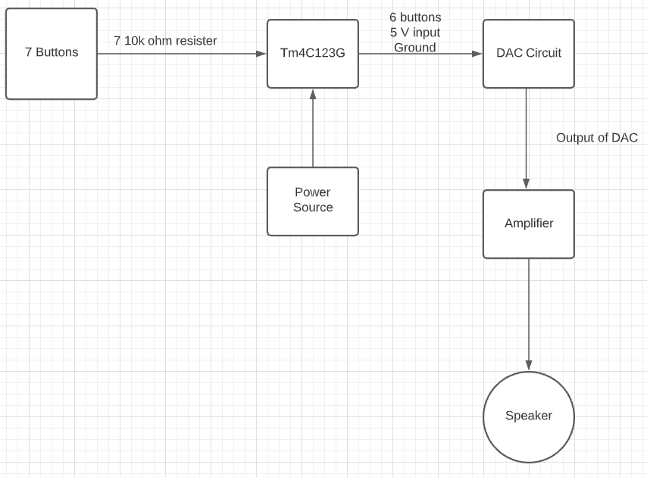

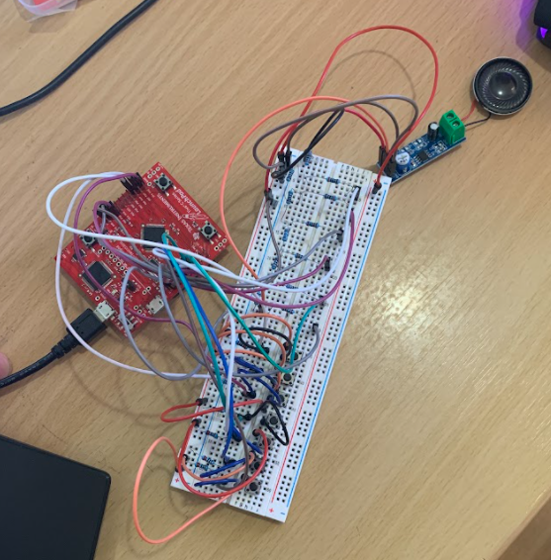

Software Design

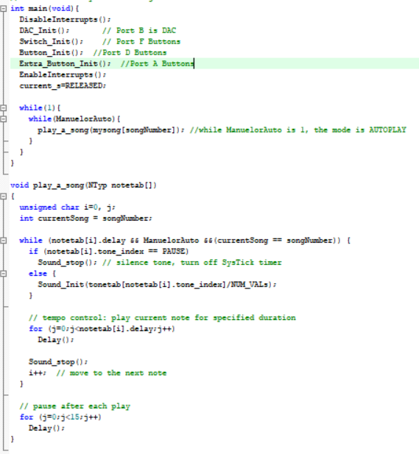

The part code responsible for making a sign wave in the systick handler, since each frequency is produced using a systick interrupt. Port B, the port connected and responsible for controlling the DAC, outputs a certain data depending on what is being passed as the reload value. The result should be a sign wave over a period of time, thus creating music.

Conclusion

Overall this project is challenging when it comes to understanding the concept of how to produce a sound using a sinusoidal wave. Understanding how the DAC circuit interacts and creates sound seems like the biggest hurdle of this project. However, putting everything together hardware and software wise isn’t that difficult once all the concepts are understood. The amplifier itself isn’t hard to understand or connect.